** OAK STREET NURSERY **

**SCHOOL**

** December 2022**

Important Dates and Themes to Note:

Dec 1& 2 Giving and Sharing

Dec 5&6  Preparing for the Holidays - We will learn about Hanukkah

Dec 8&9 Preparing for the Holidays - We will learn about Christmas

Dec 12 &13 Gingerbread Hunt

Dec 15 Movie/Relax day – Resting up before our big party

**Dec. 16 No regular classes this day – Parents must attend/ stay**

**Christmas / Hanukkah Party! Please review info sent out**

AM & PM kids attend the same party on the morning of the 16th

No lunch program or afternoon classes this day

Dec. 16 **Last day of school.**



**January 5, 2023**

**School resumes**

We will learn about dinosaurs the first week back

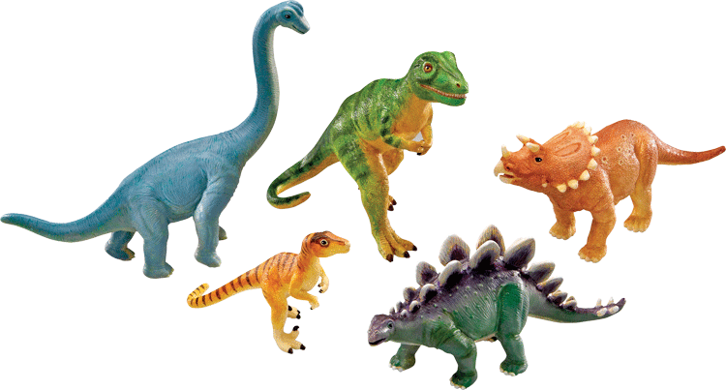

**From the teachers….**  

Happy Holidays!! It’s already December and hard to believe that we have been through

three months of school.

We start December off by teaching the children about what it means to give and share and that sharing doesn't always look the same. We have been working hard at teaching that a big part of sharing is being the person who waits for a turn. Following that, we will learn about Hanukkah and Christmas. Next up will be our annual hunt for our Gingerbread Man. If you are celebrating a holiday other than those two, please let the teachers know so that we can include it into the program.

We feel quite strongly that learning about different holidays gives the children a solid foundation of their traditions and beliefs. It also fosters tolerance, understanding, interest and appreciation of others. While sharing, giving, peace, love and togetherness are important throughout the year, it is especially nice to remind ourselves of the importance throughout the holidays.

One more thing… this month we are practicing our songs and making decorations for the party day. There will be many days where children make crafts but will leave them at school for the party day. If your child is talking about crafts they forgot at school, they may be referring to these items.

**Quiz of the month**

Where is the arctic? What animals live in the arctic?

Where is the Antarctic? What animals live there?

Can polar bears and penguins live together?

Do you know? Ask your child and see if they can tell you!

**Christmas/ Hanukkah Party Information**

Parents and grandparents are invited. Please arrange to have siblings looked after at home as it is a very special time for your child. Infants are welcome! Any donations of baking (see orange caption below) for the parties would be appreciated. Sign-up sheets will be up starting this week. Any leftover food items will be donated. Please sign up if you are able to bring something. Parents must stay at the party with their children to play games, do crafts, enjoy entertainment as well as have snack/tea and coffee in the gym.

* **All children attend the party on the morning of December 16, even if it is not their regular school day/time.**

Party time is 9:30 – 11:30 for am children and pm children

**Party Snack Announcement**

This year we have a few life-threatening allergies and food restrictions. Any child with a special food circumstance will not get snack at the party that was baked at other people’s homes as cross contamination is a concern but please take those allergies into consideration when doing baking for the party day. Things containing baked eggs are OK. – no nuts please, they contain oils that are difficult to wipe up) If you are looking for allergy safe recipes, try checking out vegan recipe websites. Listed ingredients attached to your snack donation is super helpful. If your child has restrictions, we will have a labeled snack plate for them. Please connect with us at the party for information.

Thank you!!

**News around the School**

* There are still quite a few children who are not feeling well. Each day there seems to be a handful that are away. Hopefully we won't see much more of the pesky viruses. Thank you for keeping children home if they are not feeling 100%. It is difficult for kids who are sick to get better when at school, germs quickly spread to others and a sickness cycle seems to be never ending. Our policy requires you to keep children home for a full 24 hours fever free, throw up free and diarrhea free before returning to school.

**Registration for the 2022-2023 School Year**

Registration for next year will take place at the end of January/beginning of February. Please keep an eye out for more information. Registration will open to families who are already enrolled before it opens to the rest of the public.

In the past we have found that **word of mouth** has been the most effective method of advertising for the school. If you know someone with children who is looking for a school, please pass on our number (204-488-1133) and have them call to get themselves on our mailing list. Also, feel free to guide them towards our website ( oakstreetnurseryschool.com ) It will give them an idea of the curriculum content.

If you are unsure about what to do for your 4 year old, please talk to us to find out more about the educational value of our afternoon program. It is quite different from the 3 year old program as it focuses much more on kindergarten readiness. We feel strongly that the children leaving here and going into the school system are more than prepared for the kindergarten curriculum. Some people in the past have chosen to attend the school system in the mornings and then do Oak Street in the afternoons. This seems to work well for many children. Feel free to ask us any questions you may have regarding registration for next year.

**Ask us about our lunch hour program if you are looking to extend your child's school hours.**

REMEMBER… Our afternoon program is **open to kindergarten children**! The kindergarten children bring a different dynamic to the afternoons and they seem eager to continue on for a third year with us. If you have any questions about the kindergarten component of our program please ask us.

*A belated "Thank You" to our 2021-22 board members. We are so thankful for your support and guidance. We recently held our AGM where a couple of people volunteered to be new members. I would like to thank them, and welcome them to the board. Based on the AGM I anticipate that we will have a strong and productive board again this year. I look forward to working with all of you. If you were not at the meeting but would like to be on the board (or would simply like to attend meetings) let me know, I will add you to the email list.*

**

Exciting news about fees!

Please keep an eye out for an email regarding an announcement about a fee credit. It will be out within the next week. Also, please make sure that you have paid your Nov/Dec fees.

Great big huge thank you to all those who have been so generously donating snack and classroom items. This really helps us operate within our budget and we thank you so much for your support!

Just a little reminder to make sure that all children have indoor shoes at school and that all winter items are labeled with names or initials.

**Have a joyous, peaceful holiday **